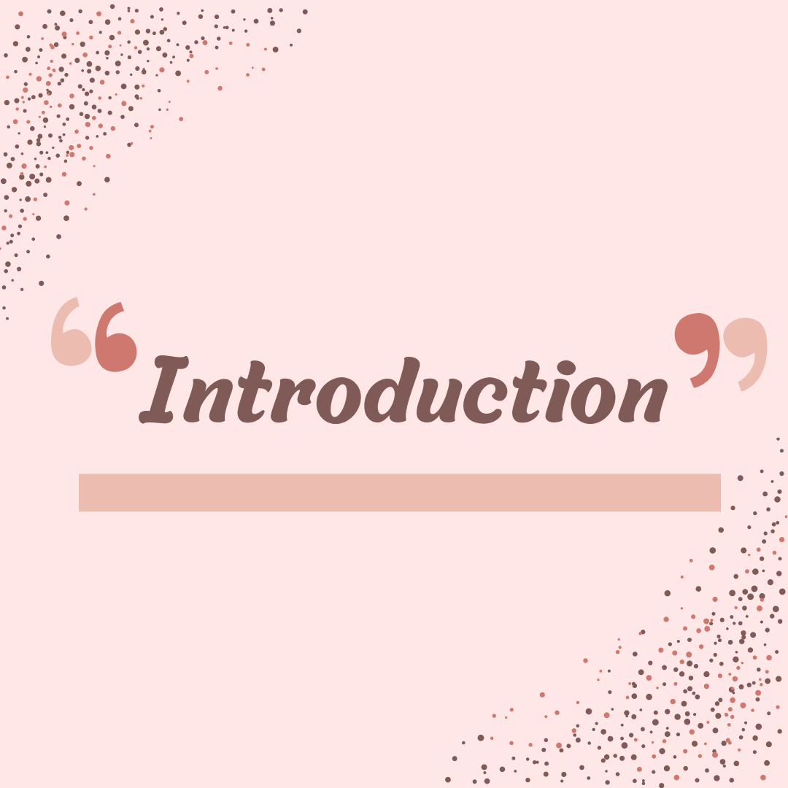

**INTRODUCTION**

Mixed anxiety-depressive disorder (MADD) is a new diagnostic category that describes patients who have limited and equal anxiety and depressive symptoms, as well as some autonomic features. Patients do not meet the diagnostic criteria for anxiety or depression. Autoimmune symptoms, such as panic attacks or intestinal depression, are involuntary physical symptoms caused by an overactive nervous system. Mixed anxiety and depression is defined by the World Health Organization's ICD-10 as a condition in which anxiety and depression symptoms coexist but are not distinct, and no type of symptom exists at a level that allows for diagnosis. Both diagnoses should be recorded and this category should not be used if both anxiety and depression symptoms are present and severe enough to excuse the individual diagnosis.**[Kara S, et al., Yazici KM,et al., Güleç C, et al.,Unsal I.et al., Mixed anxiety-depressive disorder and major depressive disorder: comparison of the severity of illness and biological variables*. Psychiatry Res*. 2000 Apr 24;94(1):59-66.]**

* 1. **Anxiety:**

**Definition:**

Anxiety is defined by the ***American Psychological Association (APA****)* as "a feeling of tension, worried thoughts, and physical changes such as increased blood pressure."

Anxiety is a mental and physical state characterized by unmet expectations. It is marked by increased emotional distress and anxiety, which causes stress, as well as unpleasant activation of many bodily systems, all in order to facilitate a response to an unknown danger, real or imagined. Panic in anticipation of a negative outcome, as well as physical sensations like courage and a racing heart, are all designed to make you feel uncomfortable. Anxiety is meant to draw your attention and motivate you to make the necessary changes to protect what you value. Anxiety is normal and can even be beneficial. Anxiety can be thought of as the cost of being able to think about the future. It is especially difficult to distinguish between normal behavior and pathology in the case of anxiety. Anxiety plays a dynamic role in human development, implying that safety

precautions are necessary. Because anxiety can be measured over time, some researchers believe

that excessive anxiety is simply a more severe manifestation of a personality trait, rather than a different condition or illness. However, different businesses may be involved in distribution. **[[Adam Felman](https://www.medicalnewstoday.com/authors/adam-felman), et al., What do you know about anxiety,(2020)]**

When anxiety prevents or limits developmentally appropriate adaptive behavior, it can become symptomatic at any age. (**[Klein & Pine, 2001](https://www.oxfordclinicalpsych.com/view/10.1093/med-psych/9780199928163.001.0001/med-9780199928163-bibliography-1" \l "med-9780199928163-bibItem-443)**).

Many young children, for example, experience separation anxiety as a normal part of growing up. Similarly, due to the social changes that many young people go through, questions about social issues arise during adolescence. The most common mental illnesses and disabilities are anxiety disorders. Anxiety is increasingly being linked to cardiovascular risk factors and diseases like atherosclerosis, metabolic syndrome, and heart disease. Because inflammation of the lower extremities is clearly involved in the etiology of these somatic conditions, it has been hypothesized that inflammation plays a role in anxiety disorders and may be linked to cardiac load. Anxiety disorders are also linked to depression, which has been linked to physical disability on numerous occasions. In contrast to depression, however, few studies have looked into the link between anxiety disorders and inflammation.**[Beesdo, K., Knappe, S., & Pine, D. S. (2009). Anxiety and anxiety disorders in children and adolescents: developmental issues and implications for DSM-V. *The Psychiatric clinics of North America*, *32*(3), 483–524.]**

**2.2 What is normal anxiety?**

Anxiety is natural and healthy; it can motivate you to act on your concerns and protect you from harm. Anxiety can even be necessary for survival in some situations. If you were standing on the edge of a curb and a car swerved toward you, for example, you would immediately sense danger, feel alarmed, and jump back to avoid the car. The "fight or flight" response, which is a normal anxiety response, prompts you to fight or flee from danger.

When we sense danger or believe danger is approaching, the brain sends a signal to the nervous system, which releases adrenaline. Adrenaline boosts our alertness and energy, as well as giving us a burst of strength, preparing us to attack (fight) or flee to safety (flight). Adrenaline overproduction can have negative consequences. Nervous, tense, dizzy, sweaty, shaky, or breathless are some of the symptoms. These effects are unpleasant, but they are not harmful to the body and do not last long.

**2.3 Types of Anxiety:**

Anxiety is manifested in a number of different diagnoses.

1. **Generalized Anxiety disorder**, in which anxiety reflects any of the key aspects of life — work, love, money, health — is most common in adults.
2. **Social Anxiety Disorder**, which focuses on the fear of being criticized by others, is on the rise among adults.
3. **Phobias** often direct certain things or experiences. Sometimes anxiety roars at the scene in an instant, intensifying and building up to a frightening crescendo in minutes. Panic may strike randomly, without the blue, or it may be paralyzing. Anxiety by all means is acceptable to treatment.
4. **Agoraphobia** is a type of anxiety disorder in which you are scared and often avoid places or situations that can make you feel nervous and make you feel trapped, helpless or embarrassed.
5. **Anxiety disorders due to a medical condition** include symptoms of severe anxiety or panic that are directly caused by a physical health problem.
6. **Selective mutism** is a constant failure of children to speak in certain situations, such as school, or they may speak in other situations, such as at home with close family members. This can affect school, work and community service.
7. **Separation Anxiety disorder** is a child's disorder characterized by excessive anxiety in the child's developmental stage and related to separation from parents or other parents.
8. **Substance-induced Anxiety disorder** caused by a drug is characterized by symptoms of severe anxiety or panic which is a direct result of drug abuse, drug use, and exposure to a toxic substance or drug withdrawal.
9. **Some specific anxiety disorders and unspecified anxiety disorders** that are not mentioned by words of anxiety or phobias do not meet the specific process of any other anxiety disorders but are important enough to stress and distract.

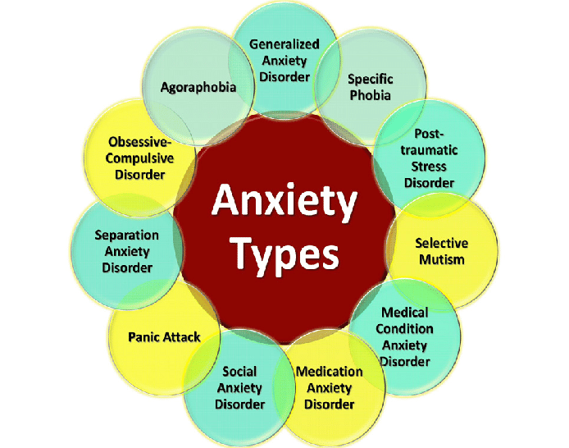

Anxiety Disorders: Recent Global Approach to Neuro-pathogenesis, Drug Treatment, Cognitive Behavioral Therapy, and Their Implications - Scientific Figure on ResearchGate.

**2.4 Symptoms:**

Common anxiety signs and symptoms include:

* Feeling nervous, restless, or tense
* Having a sense of impending danger, panic, or doom
* Having an increased heart rate
* Breathing rapidly (hyperventilation)
* Sweating
* Trembling
* Feeling weak or tired
* Trouble concentrating or thinking about anything other than the current worry
* Having trouble sleeping
* Having gastrointestinal (GI) problems

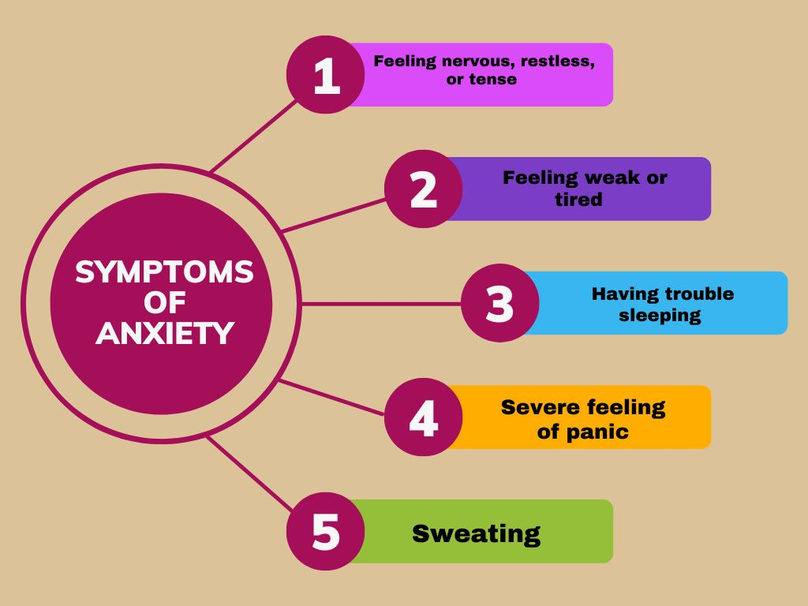

**2.5 Anxiety Disorder Causes:**

The causes of anxiety disorders are unknown. Traumatic events, for example, appear to trigger anxiety disorders in people who are already anxious. Inherited characteristics can also play a role.

**2.6 Medical Causes:**

Anxiety may be linked to an underlying health issue in some people. Anxiety and symptoms are sometimes the first signs of a medical problem. If your doctor suspects a medical cause for your anxiety, he or she may order a checkup to look for symptoms.

Examples of health problems that can be linked to anxiety include:

* Heart disease
* Diabetes
* Thyroid problems, such as hyperthyroidism
* Respiratory disorders, such as chronic obstructive pulmonary disease (COPD) and asthma
* Drug abuse or withdrawal
* Withdrawal of alcohol, antidepressants (benzodiazepines) or other medications
* Chronic pain or irritable bowel syndrome
* Unusual plants that produce certain anti-flying hormones
* Sometimes anxiety can be the result of certain medications.

It is possible that your concern may be due to poor health if you:

* You do not have blood relatives (such as a parent or a sibling) who has a anxiety disorder
* You did not have anxiety disorders as a child
* You do not avoid certain things or situations because of anxiety
* You just have a sudden anxiety that seems unrelated to life events and you have no previous history of anxiety.

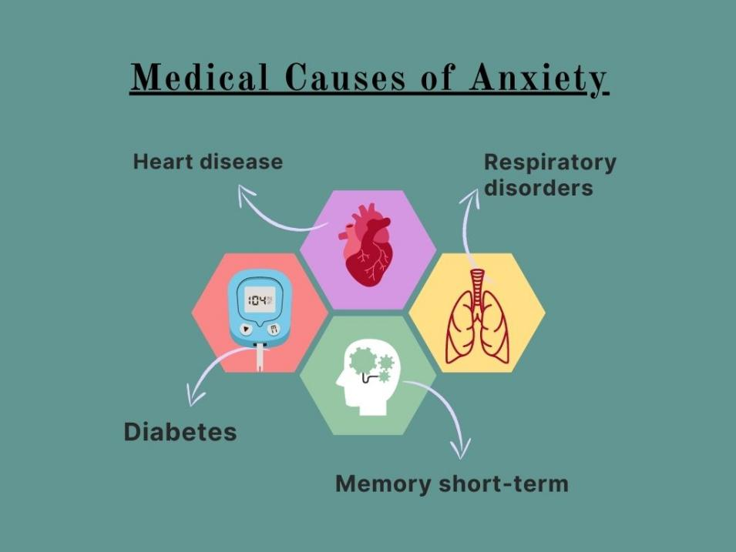

**2.7 Risk factors include:**

These factors could make you more likely to develop an anxiety disorder:

* **Trauma**: Children who have been subjected to abuse or trauma, or who have witnessed traumatic events, are more likely to develop anxiety disorders later in life. Anxiety problems may develop in older people who have experienced a traumatic event.
* **An illness causes stress:** When you have a medical condition or a serious illness, you may be concerned about your treatment and future.
* **Build-up of stress:** Excessive anxiety can be caused by a major event or a series of stressful living conditions, such as a death in the family, job stress, or ongoing financial worries.
* **Individuality:** Anxiety disorders are more common in people with certain personality traits than in others.
* **Other mental health conditions:** Anxiety disorders are more common in people who have other mental health issues, such as depression.
* **Having a blood relative who suffers from anxiety:** Anxiety disorders can be passed down through generations.
* **Alcohol or drugs Anxiety:** can be caused or increased by drug or alcohol abuse or withdrawal.

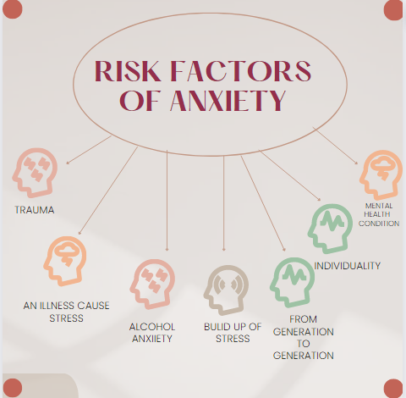

**2.8 Complications:**

Anxiety disorders do more than just make you feel anxious. It can also cause or exacerbate other mental and physical conditions, such as:

* Depression (which is frequently associated with anxiety disorders) or other mental health disorders.
* Substance abuse
* Sleep disturbances (insomnia)
* Digestive or bowel issues
* Headaches and chronic pain
* Social isolation
* School or work problems
* Poor quality of life
* Suicide

**2.9 The Diagnosis of Anxiety:**

Because current research indicates that the various anxiety disorders differ in behavioural pattern, natural history, and neurochemical basis, it is crucial to understand the distinctions between them and to become familiar with their diagnostic criteria. Others, like posttraumatic stress disorder, are brought on by a single traumatic event or a string of traumatic events. Some anxiety disorders, like panic disorders, are primarily genetically transmitted. Each anxiety disorder needs to be identified, handled, and managed differently as a result of these variations. Given how closely social anxiety and social phobias can resemble speech disorders, speech-language pathologists would benefit from having a thorough understanding of the entire spectrum of anxiety disorders.

**2.10 Analysis of Anxiety Disorder:**

Most patients with anxiety disorders seek treatment in primary care, frequently for physical complaints, but frequently the anxiety disorder is not recognised. Interventions for the co-morbid medical disorder are less effective when anxiety disorders are present and untreated. Other people with anxiety disorders also ask for behavioural help, but they typically do so because of relationship problems, work-related stress, or other psychosocial issues. Speech and language therapy is sought by other people with anxiety disorders. Because the problem with background anxiety is not recognised, many people in each group will not receive effective treatment.

**2.11 How Can We Induce the Relaxation Response?**

The relaxation response can be induced by a variety of everyday activities, such as taking a leisurely stroll along the beach, listening to calming music, practising a craft, or working quietly in a garden. Humans frequently believe they are relaxed despite having tense or overactive physiological systems in their bodies. It's crucial to develop self-quieting abilities that calm both the body and the mind.

**2.11.1 Quieting Techniques:**

Learning relaxation or meditation techniques is the most effective way to trigger the relaxation response. There are countless techniques for achieving both physical and emotional relaxation. Every technique teaches some form of self-control.

1. **Autogenic Training:** Listening to a series of phrases that describe the feelings of heaviness, looseness, warmth, and inner peace that come with relaxation is known as autogenic training. The person enters a deep state of mental and physical relaxation as the phrases take effect on the body.
2. **Calm scene**: Imagine yourself in a calm, comfortable setting and use your imagination to feel the calming effects of being there on your body and mind. This is one of the simplest forms of relaxation.
3. **Diaphragmatic Breathing**: Breathing fully and slowly from the diaphragm causes a deep state of relaxation as well as numerous significant physiological changes in the body and nervous system. Many religious schools of meditation include paced, deep breathing because it fosters inner peace.
4. **Slow correct diaphragmatic breathing**: The most efficient way to improve respiratory sinus arrhythmia (RSA), a measure of synchrony between the respiratory and cardiovascular systems, is slow, correct diaphragmatic breathing (5 to 7 breaths per minute [BPM]). Slower diaphragmatic breathing and improved RSA lead to a lower heart rate and greater autonomic nervous system homeostasis, which lessens the symptoms of anxiety.
5. **Meditation:** There are numerous methods for meditation. Every meditation technique sharpens mental focus and fosters inner peace. Additionally, regular meditation has a powerfully calming effect on the body.
6. **Progressive muscle relaxation:** Each muscle group in your body is alternately tense and relaxed by the person using progressive muscle relaxation. An individual's capacity to release tension is improved by first tensing their muscles. The ability to distinguish between tense and relaxed muscles heightens one's awareness of tension when it manifests in daily life.
7. **Passive muscle relaxation:** This quick relaxation technique quickly relaxes all body muscle groups. Patients with chronic pain can more easily tolerate this technique because it skips the progressive muscle relaxation step that involves tensing the muscles.
8. **Visualization**: Visualization entails imagining a series of images that bring about calm, physical healing, pain relief, and other health-improving effects.

**2.12 Prevention:**

Although it's impossible to predict what will cause someone to develop an anxiety disorder, you can take steps to lessen the severity of symptoms if you're worried:

1. Seek assistance early If you wait, anxiety, like many other mental health conditions, can become difficult to treat.
2. Keep moving:Engage in activities that make you happy and make you feel good about yourself. Social interaction and caring relationships can help you feel less anxious.
3. Don't drink or use drugs Anxiety can be caused or increased by alcohol and drug abuse. Quitting any of these things can be stressful if you are addicted to them. If you are unable to stop on your own, seek medical assistance or join a support group.
4. Be aware of situations, occupations, and people that cause you stress.
5. If unavoidable, confront and overcome situations that provoke anxiety.
6. Find a relaxation technique that works for you. Use it regularly.
7. Develop and maintain a strong social support system.
8. Express your emotions when they happen.
9. Challenge irrational beliefs and thoughts that are not helpful to you.
10. Correct misperceptions. Ask others for their points of view.
11. Work with a therapist.

